**Google’s Self-Driving Cars**

***What is a Self-Driving Car?***

**It uses many sensors, cameras, radar, and AI (Artificial Intelligence) to travel between distances without a human operator driving it.**

**Examples: Tesla, BMW, Google [Waymo], Mercedes etc.**

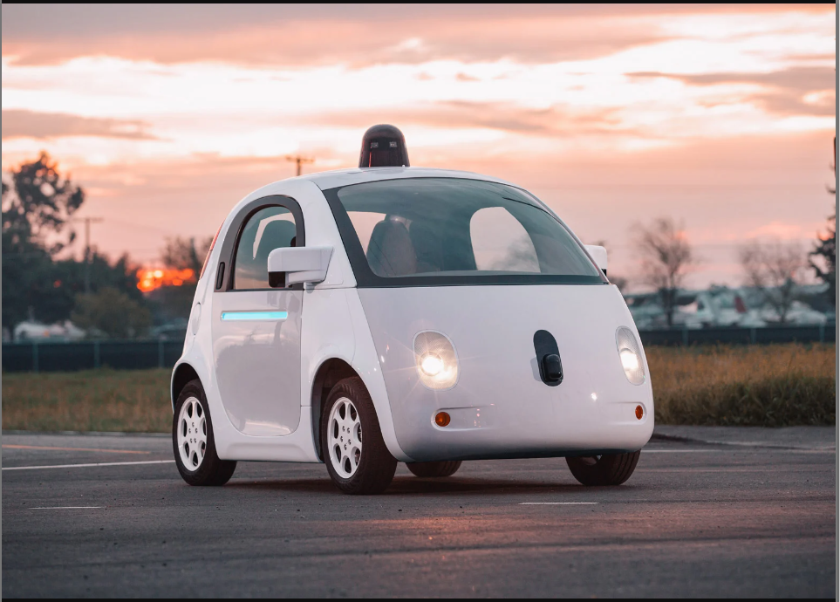

**Google Self-Driving Car**

***How do they work?***

**These vehicles use AI technology to power their self-driving car systems. Developers of these cars use numerous amounts of data from image recognition systems, machine learning and neural networks to make it drive autonomously.**

**Neural networks used in the system identify patterns in data that are fed to ML algorithms. The data includes pictures from cameras on the cars that help the ML to learn about the usual environment of a road or street.**

***Google’s Self-Driving Car Project, Waymo***

**Google uses a mix of sensors, lidar [technology like RADAR], cameras, combines all the data those systems generate to identify everything and predict what objects will come next. All these happen in seconds. The more these systems drive, the more data they collect that is incorporated in its deep learning algorithms, allowing it to make more driving choices.**

**The following outlines how Google Waymo vehicles work:**

* **The driver (or passenger) sets a destination. The car's software calculates a route.**
* **A rotating, roof-mounted Lidar sensor monitors a 60-meter range around the car and creates a dynamic three-dimensional (**[**3D**](https://www.techtarget.com/whatis/definition/3-D-three-dimensions-or-three-dimensional)**) map of the car's current environment.**
* **A sensor on the left rear wheel monitors sideways movement to detect the car's position relative to the 3D map.**
* **Radar systems in the front and rear bumpers calculate distances to obstacles.**
* **AI software in the car is connected to all the sensors and collects input from**[**Google Street View**](https://www.techtarget.com/whatis/definition/Google-Street-View)**and video cameras inside the car.**
* **The AI simulates human perceptual and decision-making processes using deep learning and controls actions in driver control systems, such as steering and brakes.**
* **The car's software consults**[**Google Maps**](https://www.techtarget.com/whatis/definition/Google-Maps)**for advance notice of things like landmarks, traffic signs and lights.**
* **An override function is available to let a human take control of the vehicle.**

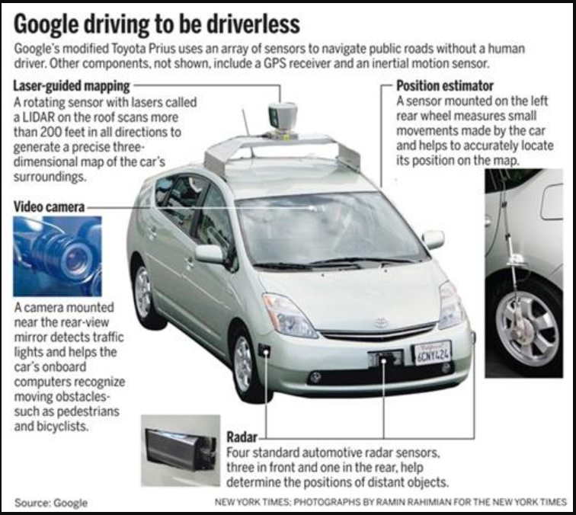

**How Google Self-Driving Car Works**

**Source:** [**https://www.techtarget.com/searchenterpriseai/definition/driverless-car#:~:text=AI%20software%20in%20the%20car,such%20as%20steering%20and%20brakes**](https://www.techtarget.com/searchenterpriseai/definition/driverless-car#:~:text=AI%20software%20in%20the%20car,such%20as%20steering%20and%20brakes)**.**